EVOLUTION OF LIBRARIES

Libraries collect the history of human race and his living in this planet - earth. The history started only after the invention of the writing system – approximately 5300 years ago. But there is a pre historic period which is the period between the use of the first stone tools 3.3 million years ago by hominines and the invention of writing system. The history of libraries starts only in the historic age. The ancient history of library will take us to 2600 BC to Sumer, in Mesopotamia which is the present day Sothern Iraq. There we can see first libraries with clay tablets in cuneiform script. (Casson, 2002) There are evidences of such libraries in various places of ancient civilization like Ugarit – ancient port city in Northern Syria, Nippur - one of the most ancient Sumerian cities, Nineveh – one of ancient Assyrian cities. Nineveh library shows that there existed a classification system. (Encyclopedia, 1954) Ashurbanipal, King of Assyria (668-around 630 BC) is the oldest Royal library which was survived the long past centuries. There are more than 30,000 cuneiform tablets and fragments at his capital, Nineveh (modern Kuyunjik). Other than historical inscriptions, there are letters, and administrative and legal texts. Also found thousands of divinatory, magical, medical, literary and lexical texts. This is treasure-house of learning and it holds unprecedented importance to the modern study of human civilizations. (TheBritishMuseum, 2018) No human growth and development is possible without linking and bridging the past with the present to march towards future. The British Museum authorities undertook Ashurbanipal Library Project with a goal to bring Ashurbanipal’s astonishing library back to life with the application of modern technologies. Their vision is to open the library to the new readers.

Among the great libraries of the ancient world, the library of Alexandria in Egypt stands renowned prime position with its size and significance. The library was conceived and made open to the scholarly people during the period 323-246 BC – the reign of either of Ptolemy I or Ptolemy II. The history shows that it was a prestigious issue for the royal emperors to build, maintain and develop the libraries. Notable remarks are due to Gaius Julius Aquila who built Library of Celsus in Ephesus, Roman Emperor Asinius Pollio who built Rom’s first public library, Emperor Augustus, and Emperor Tiberius of Han Dynasty of China. (Casson, 2002) (Houston, 2008). There was even a universal library set up to hold copies of all the books in the world as per the suggestion of Demetrius, a Greek King. “Ptolemy and his successors wanted to understand the people under their rule and they house Latin, Buddhist, Persian, Hebrew and Egyptian works – translated into Greek.” (Krasner-Khait, 2001).

The libraries were grown, flourished, transformed, and shaped under various rulers in various countries. Special mention is needed for the libraries of European Middle Ages, where four different types of libraries were established: imperial, patriarchal, monastic and private. Each had its own purpose and, as a result, their survival varied. We can see a direct relationship between the growth of Christianity and growth of libraries. “After the Roman Empire disintegrated and the contents of its grand libraries were destroyed or dispersed, monasteries emerged throughout Europe and gathered remnants of these ancient libraries. One key activity of many of these monasteries was the copying of Bible manuscripts as well as others by hand. The Benedictine monasteries, for example, lived by the “Rule of St. Benedict,” which commanded the reading and copying of books.” (Awake, 2005) Historian Elmer D. Johnson says: “The role of the monastery library in the preservation of Western culture cannot be denied. For more or less a thousand years, it was the intellectual heart of Europe, and without it western civilization would have been a far different world.” One of the most important monastery libraries was the library at the abbey of Montecassino in Italy. The Abbey of Montecassino was founded by St. Benedict around 529 AD.
Libraries of 21st century:
According to the mode of service rendered to the users, the libraries are categorized into Academic, Special, Public and National Libraries. In Academic Library itself there are school, college and university libraries.
It is quite interesting to look through the biggest libraries of the present century. Established in the year 1800, The Library of Congress is the largest library in the world, with more than 167 million items on approximately 838 (1349 km) miles of bookshelves. The collections include more than 39 million books and other printed materials, 3.6 million recordings, 14.8 million photographs, 5.5 million maps, 8.1 million pieces of sheet music and 72 million manuscripts. The library receives 15000 items each working day. The collection contains materials in some 470 languages. The Library holds the largest rare-book collection in North America (more than 700,000 volumes), including the largest collection of 15th-century books in the Western Hemisphere. The collection also includes the first known book printed in North America, “The Bay Psalm Book” (1640). The oldest written material in the Library is a cuneiform tablet dating from 2040 B.C. The Library's Prints and Photographs Division contains more than 15 million visual images, including the most comprehensive international collection of posters in the world, the most comprehensive visual record of the Civil War, and pioneering documentation of America's historic architecture. More than 1.2 million images are accessible on the Prints and Photographs online catalog at (LibraryofCongress, Fascinating facts, 2018) The budget of the library is ‎$684,040,000. In short in every respect one could say that Library of Congress is a gateway to knowledge from the very ancient to the most recent piece of information. Culture, art, science, technology, medicine, engineering, cinema, literature, folklore, music, comic even news papers .. everything is preserved here systematically with easy access.
Established in the year 1973 (1753), British Library holds second position in the world by the size of the library having 625 km of shelves, which grows by 12 km every year. The collection includes well over 150 million items, in most known languages. 3 million new items are added every year. Over 16,000 people use the collections each day (on site and online). The library has 1200 onsite seating arrangement for the readers. The library operates the world’s largest document delivery service providing millions of items a year to the users all over the world. The treasures of the library include Magna Carta, Lindisfarne Gospels, Leonardo da Vinci's Notebook, The Times first edition from 18 March 1788, Beatles manuscripts, the recording of Nelson Mandela's Rivonia trial speech. (BritishLibrary, 2018) As the present day libraries are not only the collection of books and reading materials, but also are providing access to all these collections to the public, we can honestly say that the libraries are the gateways to knowledge. Where else will we get the old fascinating information about the persons, events, developments, literature, etc.. In the case of new pieces of information also, as the production of information is so proliferating, it is not easy for anybody to have access to the full volumes of information that is being produced. Economics, space everything matters. Libraries are the collection point of all sorts of information that is being produced which can be accessed by the public according to their need and time.
Other than Library of Congress and British Library, there are a number of libraries which can claim somewhat same amount of honor and importance in sharing knowledge and making societies into knowledge societies. They are given below in the descending order with regard to the size of the libraries.

1 | New York Public Library  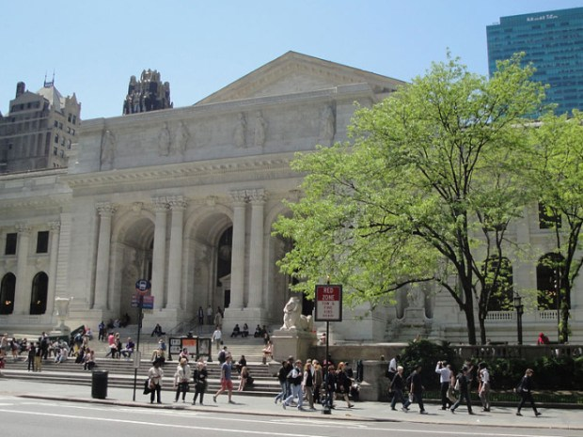  Image Curtsey -General Knowledge February 7, 2018 | - Established 1895  - The stacks contain 125 miles of shelving  - The number of Library visitors on opening day in 1911  - Most visited library in the world with annual visit of 37 million people  - Hold a 1493 unique copy of Columbus’s letter announcing his discovery of the New World  - Annual Budget : US$302,208,000 (2017)
2 | Library and Archives Canada (Wikipaedia, 2018)  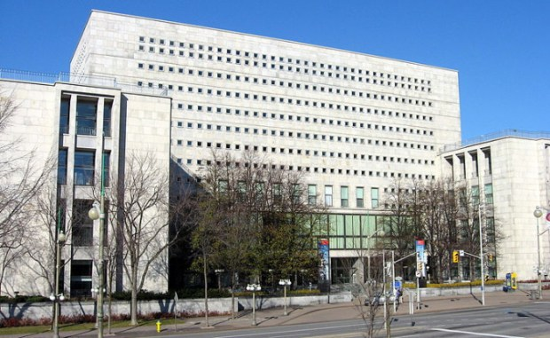  mage Courtesy: Padraic Ryan | - Established in the 2004  - 20 million books, periodicals, newspapers, microfilms, literary texts and government publications  - 167,000 linear metres of government and private textual records  - 3 million architectural drawings, maps and plans  - 24 million photographs  - 350,000 hours of film  - 425,000 pieces of art, including paintings, drawings, watercolours, posters, prints, medals and caricatures  - 547,000 musical items;  - More than a billion megabytes of digital content  - Annual budget : C$98,346,695 (2013–14)
3 | Russian State Library (RussianStateLibrary, 2018)  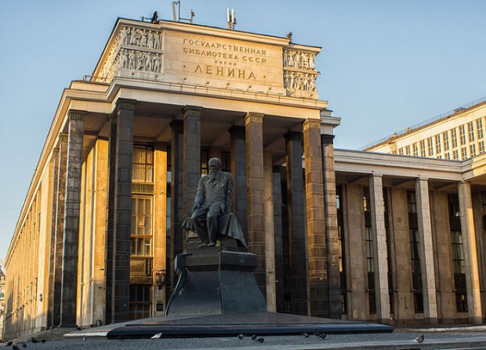  Image Courtesy: Vladimir Tokarev | - Established in the year 1862  - The Russian State Library comprises the unique domestic and foreign collections in 367 languages of the world. The size of all holdings exceeds 46 million items  - More than 800 thousand people visit the library annually and about 100 thousand new library tickets are issued.  - Budget‎: ‎1,740,000,000 (2012)
4 | National Diet Library (NationalDietLibraryJapan, 2018)  Image Curtsey -General Knowledge February 7, 2018 | - Established in the year 1948 (1872 &)1890  - 41,881,649 items  - Annual acquisition : 831184  - On site users - 722,062 (2015)  - Number access to the website : 21,346,142  - Budget 18190 million yen for the year 2018
5 | Bibliothèque nationale de France (wikipedia, 2018) (BnF, 2018)  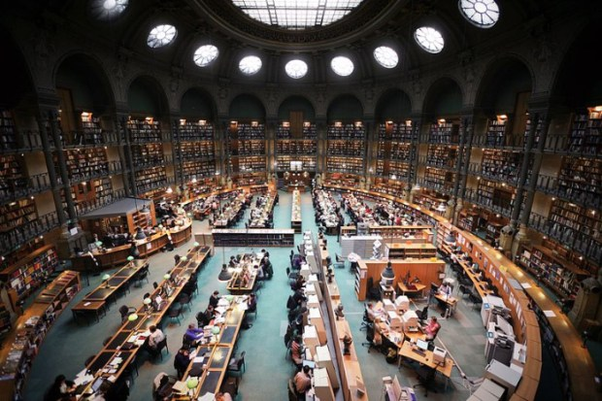  Image Courtesy: Vincent Desjardins | - Established in the year 1461  - Rare Books Reserve holds approximately 200,000 volumes selected for being rare editions or unique copies, from the Gutenberg Bible (around 1455) to the most contemporary books. reliure.bnf.fr database provides access to a selection of digitized bookbindings from collections of the Rare Books Reserve  - Gallica, the digital library for online users, was established in October 1997. As of October 2017, Gallica had made available on the Web about 4,286,000 documents, 533,000 books, 131,000 maps, 96,000 , manuscripts, 1,208,000 images, 1,907,000 newspapers and magazines, 47,800 sheets of music, 50,000 audio recordings, 358,000 objects  - 40 million catalogue entries  - Budget €254 million
6 | National Library of Russia (TheNationalLibraryofRussia, 2018)  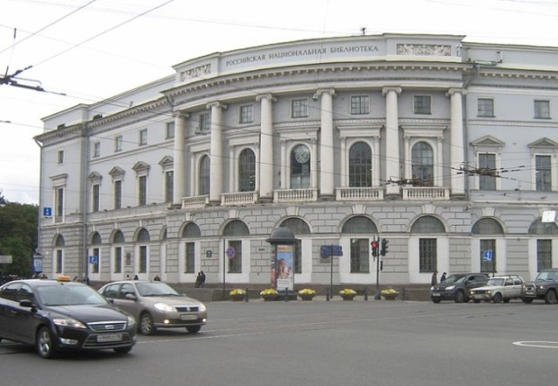  Image Curtsey -General Knowledge February 7, 2018 | - Established in the year 1795  - Total number of items (2016) : 37 890 000  - Total visit 92016) : 820 000  - Individual users visited the web site (2016):9 993 100  - Budget‎: ‎569,200,000 RUB ($23,400,000)
7 | National Library of China  Image Curtsey -General Knowledge February 7, 2018 | - Established in the year 1909  - Total collection : 37,686,187 items  - With a collection of over 37 million items it is the largest library I Asia
8 | The Royal Library of Denmark (Wikipedia, 2018)  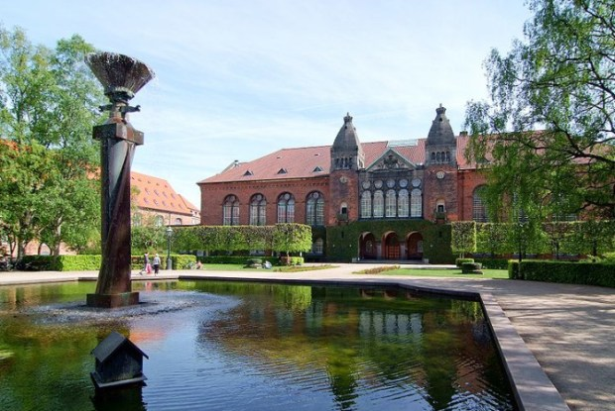  Image Courtesy: Arne List | - Established in the year 1648. In 1989, it was merged with the prestigious Copenhagen University Library (founded in 1482)  - With a collection of 35 million items it is the largest among Nordic countries (Northern Europe and the North Atlantic)  - As of 2015 the collection exceeds 35 million items
9 | National Library of Spain (Wikipedia, Biblioteca Nacional de España, 2018)  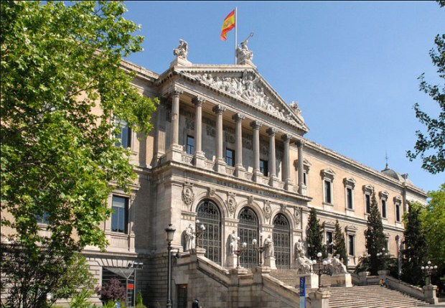  Image Courtesy: Jean-Pierre Dalbéra | - Established in the year 1712  - Collection: 26,000,000 items, including 15,000,000 books and other printed materials, 30,000 manuscripts, 143,000 newspapers and serials, 4,500,000 graphic materials, 510,000 music scores, etc  - Budget: €47,380,860  - Users for the year: 115,707 readers in 2007. The web users in the same year were 1,800,935.
10 | German National Library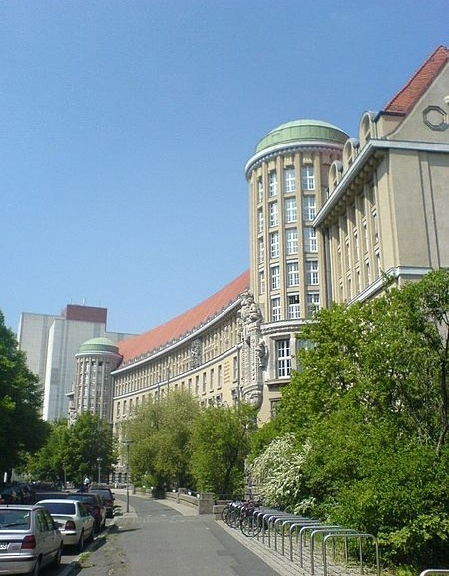  Image Curtsey -General Knowledge February 7, 2018 | - Established in the year 1912  - Collection: as on 2016 32.7 million items  - Budget: 52.3 million € (2016)
11 | Library of the Russian Academy of Sciences (Wikipedia, Library of the Russian Academy of Sciences, 2018)  Image Courtesy: Alex ‘Florstein’ Fedorov | - Established in the year 1714  - Collection 20.5 million items
12 | Berlin State Library  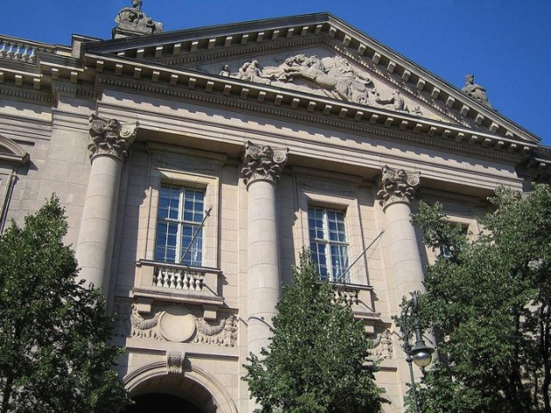  Image Curtsey -General Knowledge February 7, 2018 | - Established in the year 1661  - Size of the Library: 23,110,423  Consists of 12.3 million books; 206,700 rare books; 60,100 manuscripts; music autographs; 1,600 estate archives; 25,000 periodicals; 180,000 newspaper volumes; 4,300 databases; 2.7 million microfilms; 13.5 million images at the bpk (The Prussian Heritage Image Archive)  - Budget: €16,000,000
13 | . Boston Public Library (BostonPublicLibrary, 2018)  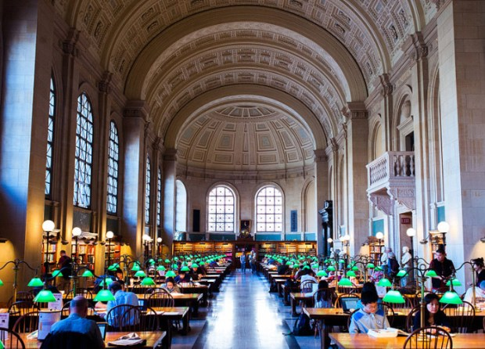  Image Curtsey -General Knowledge February 7, 2018 | - Established in the year 1848  - Boston Public Library is a pioneer of public library service in America  - All firsts in: It was the first large free municipal library in the United States, the first public library to lend books, the first to have a branch library, and the first to have a children’s room  - In the year 2017: 38,18,883 Visitors, 23 million items in the collection, 49,33,786 items borrowed, 32900 items digitized,16,28,324 downloads, 82911 new card holders, 12665 new programmes and 98,39,461 visit to bpl.org
14 | Culcutta Public Library  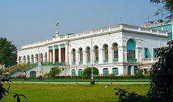  Image Curtsey:Wikipedia | - Established in the year 1903  - Over 2,270,000 books  - Over 86,000 maps  - Over 3,200 manuscripts  - Over 45 kilometers of shelf space  - Reading rooms can accommodate over 550 people

